Ge_boiling.csv

min(d(ln(I₀))/ln(I₀)): [0.00067790170593549286, -8.7192183114144139, 0.0059107729677318191, 15.248053210501471, 0.050342356588083288, 5, 30]

min(ln(I₀)): -8.72807026779

max(ln(I₀)): -1.47711499624

ln(I₀) = -8.71921831141 ± 3.62548245406

Ge_room2.csv

min(d(ln(I₀))/ln(I₀)): [0.0021077227125503631, -11.980864103396183, 0.025252339386707477, 18.527429900194189, 0.10655853869478381, 4, 15]

min(ln(I₀)): -12.1026285486

max(ln(I₀)): -11.7953802579

ln(I₀) = -11.9808641034 ± 0.155685769055

Ge_ice.csv

min(d(ln(I₀))/ln(I₀)): [0.0021022817856129368, -13.031491075251667, 0.027395866326879122, 19.700440342683606, 0.10225190062652999, 7, 22]

min(ln(I₀)): -13.2685255861

max(ln(I₀)): -12.7163067985

ln(I₀) = -13.0314910753 ± 0.277465188539

Ge_dryice.csv

min(d(ln(I₀))/ln(I₀)): [0.005645137705738346, -17.930965412082408, 0.10122276894803652, 24.331703084638871, 0.25148283565058333, 5, 15]

min(ln(I₀)): -17.9934340857

max(ln(I₀)): -16.5818739371

ln(I₀) = -17.9309654121 ± 0.713001796808

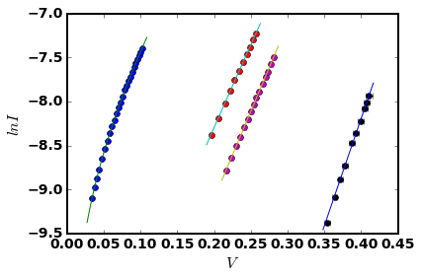

Eg Result with eq(2) (array([ 2.22016074e+00, -4.19064172e+03]), array([[ 2.03241599e-01, -5.77977937e+01],

[ -5.77977937e+01, 1.65365002e+04]]))

slope = -4190.64171777 ± 128.59432422

Eg = 0.36110759682 ± 0.0110809729181

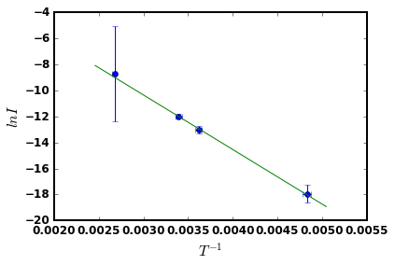

Eg Result with eq(3) (array([ 12.01935265, 4565.67806868]), array([[ 2.55913350e-01, 7.27765722e+01],

[ 7.27765722e+01, 2.08220716e+04]]))

slope = -4565.67806868 ± 144.298550221

Eg = 0.393424479178 ± 0.0124342060726

